The "New"
SMITH TERMITE

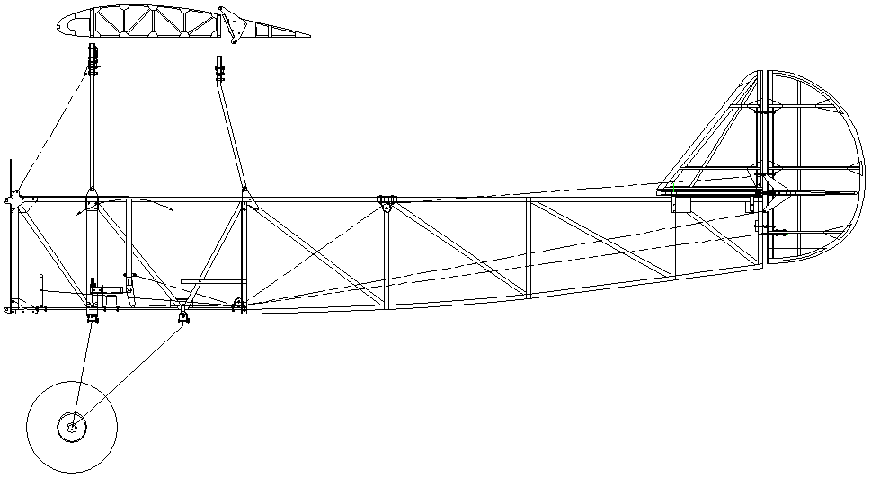

The Smith Termite was designed and first built by Wilbur L. Smith of Bloomington Illinois. This document should be considered as a GUIDE only, in the building of the Smith Termite. The aircraft was designed in the early 1950's when a lot of decisions and final design choices were left up to the builder. Ideas were borrowed from other homebuilt designs of the era such as the basic tail assembly of the Pietenpol Air Camper and many components from the J-3 Piper Cub.

There are areas of the original plans that are just not addressed, such as the Tail wheel (the original plane did not have one!), Elevator & Fin attach fittings and the Compression Tubes. There is a small reference to the Drag Wire installation in the original hand written Build Manual plus a rough drawing with little detail. However, nothing on the sheets themselves. This new guide suggests two styles of wire borrowed from the Bowers Fly Baby and the Acro Sport style of drag anti-drag wires and fittings. Builders discretion.

The original hand written Builders Manual is available for download on smithtermite.com and a re-typed and edited version, on the Smith Termite Plans and More group on Facebook to download.

The original blueprints are slowly being redrawn using the VELLUM CAD program, the illustrations of which are featured in this manual, and will be a separate plans set to the original 12 pages of blueprints. Should you need a detailed drawing of any part of this aircraft, contact me to see if one is available at present time.

The January 1958 issue of Sport Aviation featured an article about the Termite with drawings by Don Cookman which gives a few additional details that the original plans do not.

Smith Termite Builders Guide

Edited from the original hand written pages.

This accompanies Plans Set # ______________

FUSELAGE

The fuselage of the Smith Termite builds up much like that of a model airplane. The first step is to study the drawings. Next you will need to build a work table. To do so you will need:

One (1) sheet of 1/2" or 3/4" plywood.
Three (3) 2" x 4" x 16' Pine 2x4's.
One (1) 1" x 6" x 8' Pine board.
Three (3) or four (4) Saw Horses to act as table legs.
4 (4) 3/4" x 1 1/2" x 4' Pine.

Cut the sheet of plywood down the middle, and then cut off 24" from one half. This 24" piece can be used later in assembly to square up the fuselage truss. Assemble your table making sure the factory cut edges are on the same side of the finished top. Place the fourteen (14) foot top on the saw horses, or build legs from additional 2" x 4"s. Square and level the table with shims.

Draw the fuselage spruce members on the table top aligning the top longeron with the factory cut edge on the plywood. Cut the 1" x 6" Pine board into 24" pieces and secure these to the table factory edge letting it stick up off the table 3/4". Evenly space these boards the entire length of the table.

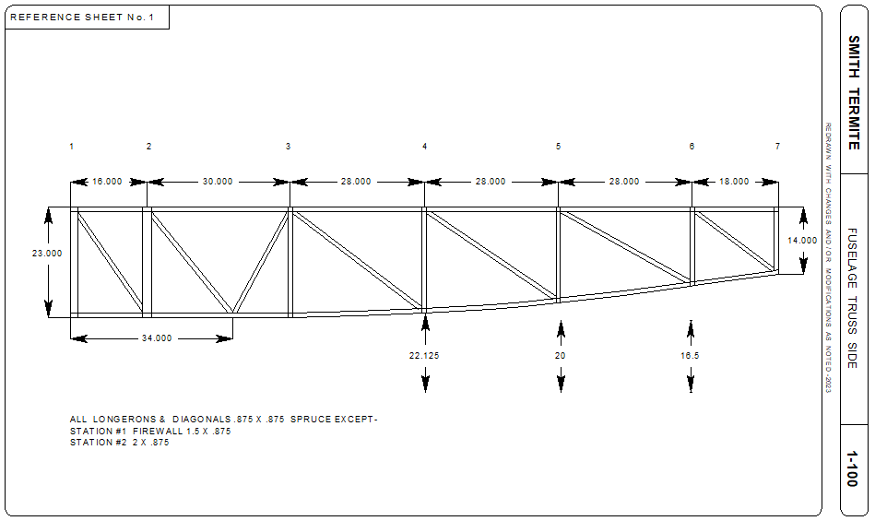
Illustration taken from CAD files.

Cut pieces of 3/4" x 1 1/2" Pine 3" long and secure them to the table on either side of all uprights and diagonal spruce members, and along the inside of the top and bottom longerons to lock the spruce in place.

You now have to decide if you are going to use stainless steel staples, or AN301 aircraft nails of the proper length. Also decide what glue or epoxy you will use. Weldwood Plastic Resin glue is FAA approved yet most builders now use a more modern T-88.

Aircraft nails are becoming difficult to find, but can be left in the structure. Staples go faster, make sure you use tack-pointed stainless staples. For the ribs and the 1/16" Mahogany Ply gussets, use a T-21 staple. For the 1/8" ply fuselage sides and gussets a T-50 is used.

Now that the jig is built and level with all the retaining blocks nailed in place, you can start cutting and fitting the Spruce members. A hand held back saw can be used to cut the fuselage members, but a good chop saw is much faster and gives perfectly square cuts. Ensure the cut pieces fit snugly in place. If you have laid out the fuselage correctly, the centerlines of all Spruce members should intersect.

Next cut the fuselage side panel and all gussets from 1/8" Mahogany aircraft grade plywood. Since both sides are identical, cut all the gussets you'll need for both the inner and outer truss assemblies. Note the inner faced gussets are notched for the cross members to sit against the Spruce longerons.

Glue and nail (or staple) the gussets and fuselage side to the fuselage truss. Use a goodly amount of glue and wipe excess away. After the outer face of the fuselage has dried (according to the manufactures' guide) remove the assembly, glue and nail all inner facing gussets. Duplicate all this again, remembering you are making the OPPOSITE side and everything will be backwards. If you nailed the outer fuselage ply on the first side, the next one will get the inner facing gussets first.

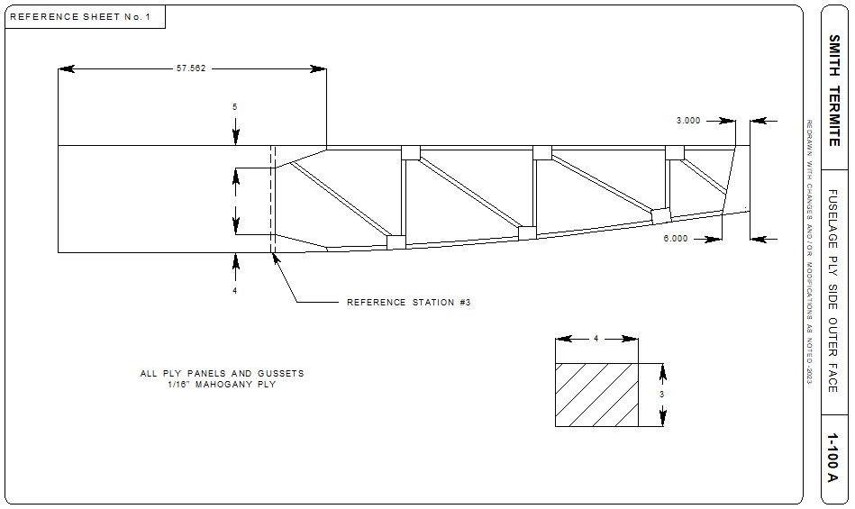
Illustration taken from CAD files.

After both sides are complete and dry, you can now reconfigure the table to assemble the fuselage structure. The fuselage is assembled upside down.

The upper and lower motor mount attach fittings (Sheet #8) need to be installed before the front cross member is put in place. Make these from 4130 steel, and finish by paint, powder-coat or plating. Seal the plywood faces where they will be attached with Spar Varnish. Use only AN hardware to assemble. It is best to drill the bolt holes in the fuselage sides with a drill press and Forstner bits using the fittings themselves as a drill guide. Install the lower mount fittings only.

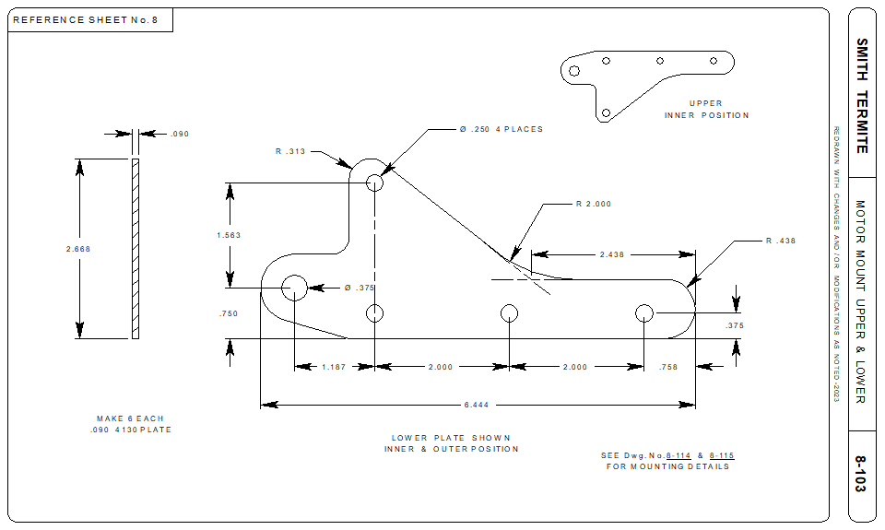
Illustration taken from CAD files.

The Cabane Strut attach fittings should also be fabricated and finished, drilling the mounting holes as you did the motor mount fittings. The strut fittings are NOT installed at this time.

Do not remove the 1" x 6" x 24" boards from the table edge. Use these to clamp one side of the fuselage to the table, top side facing down. Remove and re-nail the 3/4" x 1 1/2" x 3" blocks to align the fuselage sides 23 1/4" apart, outside face to outside face. Assure the fuselage sides are square, and plumb. The extra 24" piece of plywood left over from the table top can be clamped across the firewall (Station#1) to hold the sides in place.

Cut and fit the cross members for Stations #1 thru #3. They should all be the same width (22 1/4") except Station #1 is 20 13/16". Bore the relief pocket as shown on Sheet # Engine Mount Fittings detail upper and lower member. Glue the cross members #2 and #3 in place and clamp securely across the fuselage sides. Glue and nail gussets in place up to Station #3. Lower cross member in Station #1 is glued only to the triangular gussets.

Slowly pull the fuselage sides together at the tail post and clamp so the sides are 2 1/4" apart. This does leave a small gap between the sides. Fit the remaining bottom cross members and diagonals. Use the dimensions shown on Sheet #1 as a guide only. Actual widths can vary slightly. Cut gussets, plywood plates and tail post end plate from 1/8" Mahogany plywood and glue and nail "bottom" members in place. The cross members should fit snugly into the notches on each gusset.

Cut and fit the upper (against the table) cross members and diagonals. Cut as many 3"x4" 1/8" notched gussets as needed and glue and nail from Station #4 thru Station #7 only on the inner (bottom side of top truss- See Note #3 Sheet #1) face of the top truss layout.

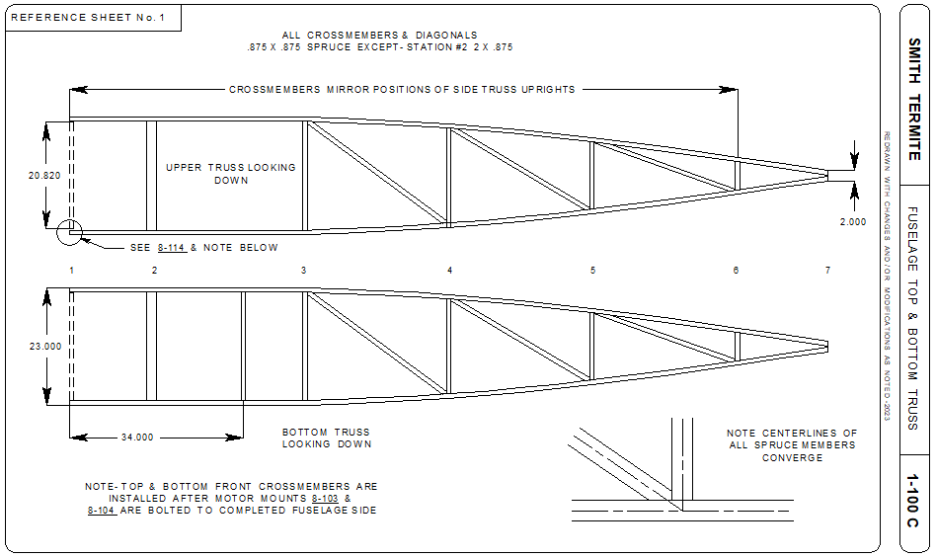
Illustration taken from CAD files.

When all gussets have dried, remove the fuselage from the table.

Install the upper motor mount attach fittings, sealing the plywood prior to bolting them in place. Clamp a finished 1/8" firewall in place to hold alignment. Glue and nail this firewall in place LAST. Cut and fit 1/4" Birch ply cockpit floor and lay in place. Glue & nail. Pre-drill holes for Control Stick Mount.

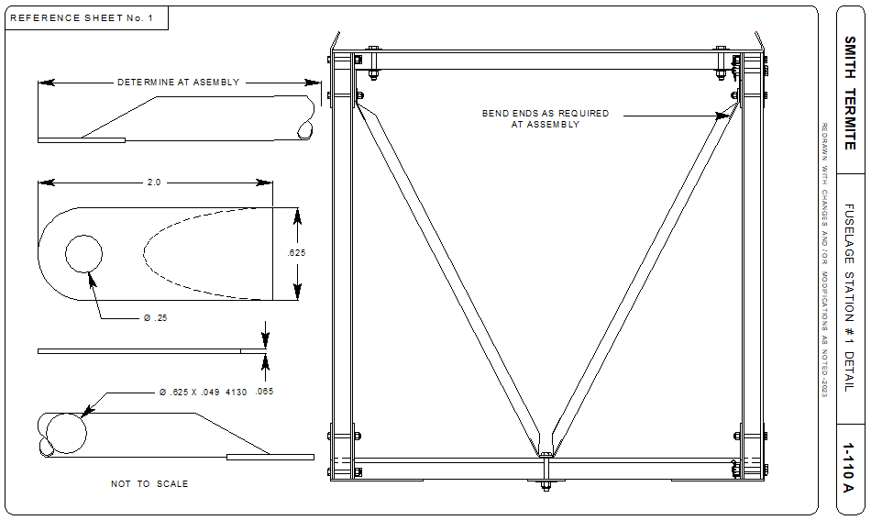

NOTE: There is a steel tube reinforcement (see illustration above) making a "V" on the inner face of the firewall. Fabricated in two (2) pieces from 5/8" diameter 4130 steel with either a flattened and drilled ends or welded lugs. Bolt these tubes run from the upper motor mount attach bolts, to the center of the lower cross member. A hint of this part is shown on Sheet #8 of the original plans.

Finish gluing and nailing remaining gussets, plywood plates and front cross member.

Cut 1/8" Mahogany or Birch seat back and glue and nail in place. Glue & nail 7/8" Spruce members for rear face of seat back and install with gussets. Be sure to cut-out ply where control surface pulleys and cables are located. The seat frame and ply bottom can be built and bolted in place. NOTE Sheet #1 Note #5 states the seat is 2 1/2" off the cockpit floor. Drawing the Termite in CAD says 5 3/4" to the top of the seat bottom from the floor. Cut the fuel tank base from 1/8" Mahogany plywood and glue & nail in place.

NOTE: Sport Aviation 1958 drawings shows a plywood web at Station #2 the plans do not mention.

Loft the Fuselage Formers from Sheet #1 and cut from cardstock or thin "junk" plywood. Assemble 1/8" ply and 1/2" x 3/4" spruce former attach bases. Clamp "junk" formers in place and locate notches for turtle deck stringers in formers 3# thru #8. After fitting, cut formers from plywood sized as described on Sheet #1. The 1/8" Mahogany ply bases that the formers are glued to should be made 2" wider than called for, and trimmed to the proper width and angle after fitting in place. Glue as an assembly and locate (clamp) in place. Less damage can happen if formers are glued & nailed last. Temporarily fit turtle deck stringers to assure proper alignment.

Note the triangular notch in the Mahogany ply base. Before clamping the former in place on the fuselage truss, run a string line from Station #1 to the tail post down the center. Align this notch with the string line and square formers.

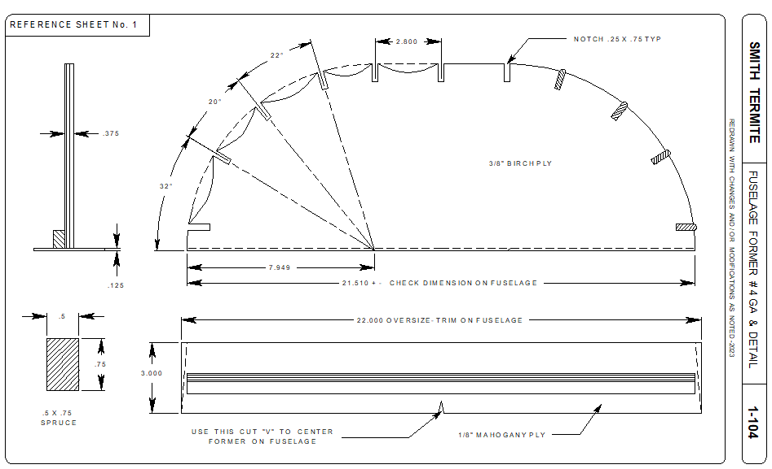
Illustration taken from CAD files.

WING ASSEMBLY

Wing assembly begins by building the 29 wing ribs. There are four (4) styles of ribs. Root, Standard Long, Standard Short and Aileron Bay. All ribs except the Root Rib is made from 1/4" x 1/4" Spruce cap strips and 1/16" Mahogany ply gussets. Again, the choice of staples or AN310 nails is yours as well as the type of glue.

The ribs are built on a solid surface such as 3/4" MDF or plywood 5' long. Lay out the full size rib drawing and make sure the spar openings are 25" center to center. Paper can shrink with humidity and copying. Use small pieces of 1/4" x 1/2" spruce or pine nailed to the sides of the cap strips to hold the spruce members in place. Chose whether you will use an aluminum trailing edge or the wooden edge3 as shown in plans. The wood trailing edge requires the ribs be trimmed as shown on the full size rib drawing.

The Root Rib is 1/2" wide, made of 1/4" x 1/2" spruce cap strips, and uses the same main rib. Note the spar openings are 15/16" wide and use 1/2" x 1/2" spruce uprights. Notched for the wing attach fittings, it is easier to cut these prior to assembly. The outer face of the root rib is plated with 1/16" Mahogany ply. The nose rib can be cut from 1/2" Birch ply or glue two (2) 1/4" nose ribs together.

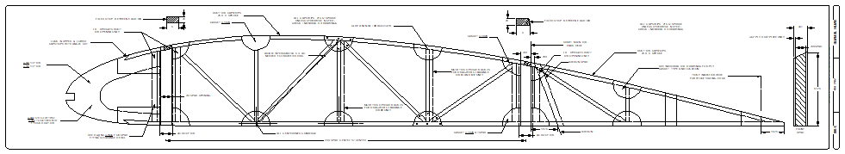
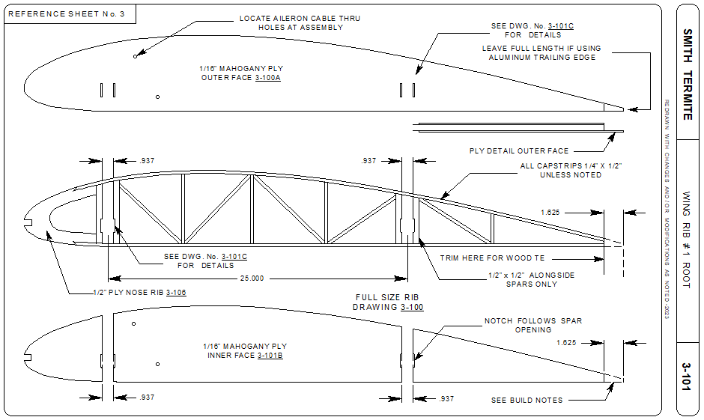
Illustrations taken from CAD files.

The Aileron Bay rib is plated only from the rear spar to the trailing edge, all other gussets are per the full size rib drawing. The short main rib at Aileron positions is simply a full size main rib that stops at the aft face of the rear spar.

Obtain aircraft grade spruce for the spars. Determine the top and bottom of your spars before cutting the bevels. As a tree grows to maturity, the annular rings become farther apart. The closets grain is the heart of the tree and should be considered the bottom of the spar. Spars are made from blanks 3/4" wide (front and rear) . Available stock is 5 1/2" x 13'. Bevel top edges as shown on rib drawing. Locate and drill holes for spar attach fittings, strut attach fittings and compression tubes. Cut 3/32" Mahogany ply plates for the root and 1/16" Mahogany ply for any other reinforcements. Glue and nail ONLY the root plates to the spar. The remainder of plates are installed after the ribs are in place.

The original plans do not address the compression tubes and drag-anti drag wire fittings. You may want to follow the Bowers Fly Baby (drawings for this are available on line as a free download) for these. The tubes themselves are 5/8" x .049" 4130 steel with .090" 4130 steel end plates. The original build notes reference Oak blocks and solid 4130 wires with a poor illustration.

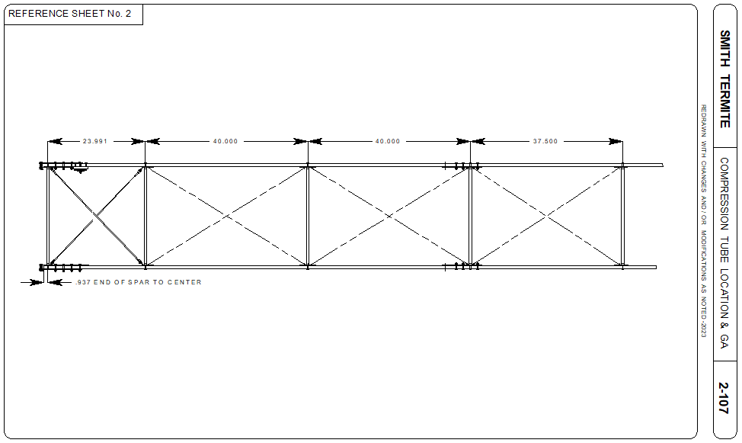
Illustration taken from CAD files.

Also note, the Acro Sport method of Oak blocks and 3/16" x 10-32 threaded rod should also be considered. The 4130 rod is a less expensive route, but more time consuming in drilling the spars. This also means a lot of thought as to the location of blocks and rod. The original hand written instructions mention this method but there are no drawings, or measurements for this. Since two (2) of the compression members locate on Spar and Strut attach fittings, the Fly Baby style will be easier, yet a bit more expensive when it comes to purchasing turnbuckles.

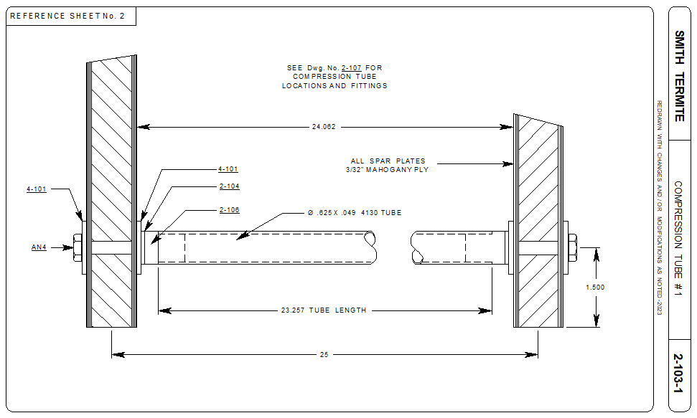
The root compression tube and Station #4 tube use the spar and strut attach fitting bolts to secure in place. Make sure you measure the tube length adjust for Drag Wire fittings, Spar and Strut attach fittings and Mahogany plates. Do this with the spars secured at 25" center to center.

The root rib can be glued and nailed in place. This holds the 25" center measurement. Slide the remaining ribs into place. DO NOT GLUE YET. Make sure the root rib and spars are square. Glue and nail the remaining Mahogany ply plates in their respective places. Glue plates to one side of the spar- then drill thru using the pre-drilled attach plate fittings holes as a guide. Then attach the plates to the opposite side and drill thru once again.

Seal the ply faces with Spar Varnish and bolt the finished (coated, painted) attach fittings in place. Install the compression tubes and fittings with AN4 hardware. Do NOT tighten (torque) the hardware at this time, only snug. Trammel the spar square. Mark the top edge of the spars front and rear in 2 places at exactly the same point. Cross measure the points and adjust the spar positions until the measurements
match. Clamp scrap boards in a "X" to keep the spars in place while gluing and nailing the ribs securely to the spar.

Install the Drag and Anti-Drag wires. Tighten the wires until a 12-14 pound pull is needed to deflect the wire 1/2". A simple fish scale can be used as a tension meter. Tighten all bolts and jam nuts.

The wing tips (Bows) require a full size jig. Layout the arc and block with 1 1/2" x 1 1/2" pine blocks in the manner of the fuselage jig. Wax paper or plastic will prevent the Bow from adhering to the jig table. Cut ten (10) strips of Spruce 1" wide, 1/8" thick and 40" long. Half this length should be soaked in boiling hot water at least 30 minutes until pliable enough to bend along the jig line without cracking. Place a single strip against either the inner or outer edge of the Bow jig. Glue and clamp strips together inserting them into the jig one at a time. Clamp tightly, level the strips and allow the glue to dry for 24 hours. This also ensures the strips dry thoroughly.

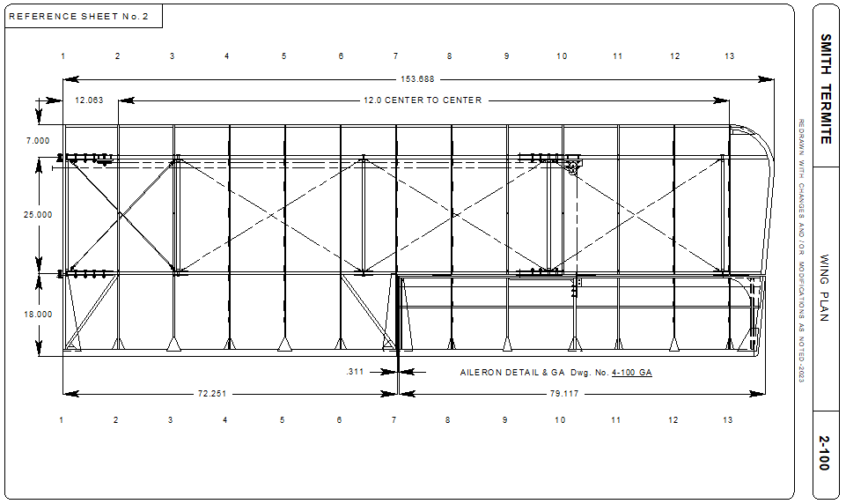
Illustration taken from CAD files.

AILERON

The Aileron construction mirrors that of the Wing. Obtain a Spar blank 3/8" x 4 3/4" x 80" long. Bevel top and bottom as shown on the full size Rib drawing. The Root Rib is 1/2" thick plated on the inner face with 1/16" Mahogany plywood. The center Aileron Horn attach rib is also 1/2", but plated on both sides with a Spruce or Oak block sandwiched between the Mahogany plates. The remaining ribs are made from 1/4" x 1/4" Spruce cap strips. Attach the ribs exactly as with the Wing. Insert a false Spruce spar as indicated on the rib drawing.

There are no details on the original plans sheets concerning the aileron but for Sheet #3.

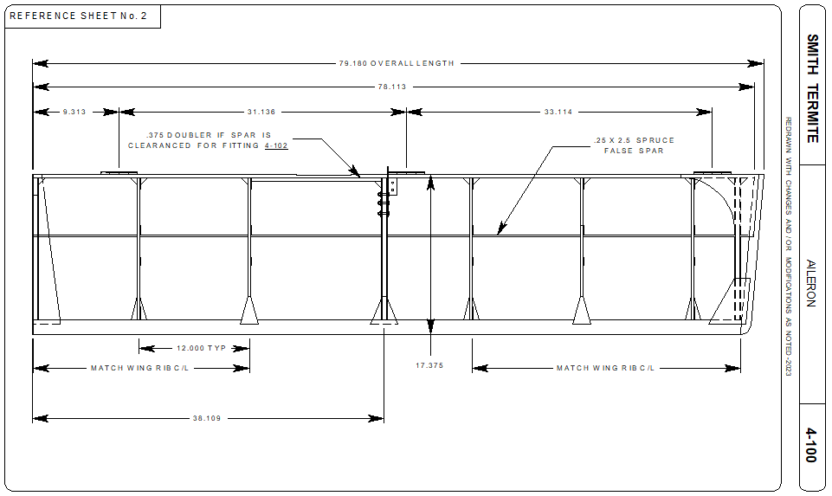
Illustration taken from CAD files.

Piano style hinges are attached to the Spar with either wood screws or by fabrication nut plates attached to the inner face of the spar and using AN3 hardware to secure. This same method(s) is used on the Wing side of the hinge. Glue and nail trailing edge gussets, root and tip gussets. Fabricate the Aileron Horn from .090" 4130 steel plate and bend as indicated on Sheet #4. Seal center 1/2" rib and attach horn with AN3 hardware.

HORIZONTAL STABILIZER, ELEVATOR,
VERTICAL FIN & RUDDER

Begin this section by obtaining aircraft grade Spruce in the dimensions shown on Sheet #5. Machine proper cross sections using either a Table Saw and a bench mounted Router. Locate and drill the 3/16" holes for the AN42B eye bolts (hinges) in the spars. You can use the Evans VP-1 design which used two (2) eye bolts on one side of the hinge. These drawings can be found on the internet.

Note also the Fin Spar on the original plans ends at the Horizontal Stabilizer. Other mentions and drawings show it ending at the bottom of the Tail Post. This moves the Fin aft 1" and poses many additional design, fabrication and fitting modifications for the builder. No appreciable benefit comes from this modification with the exception of the lower Eye Bolt (AN42B). This style requires a pocket bored into the Fin Spar for the Eye Bolt much like the cross members in Station #1 rather than a much longer Bolt passing thru the Tail Post.

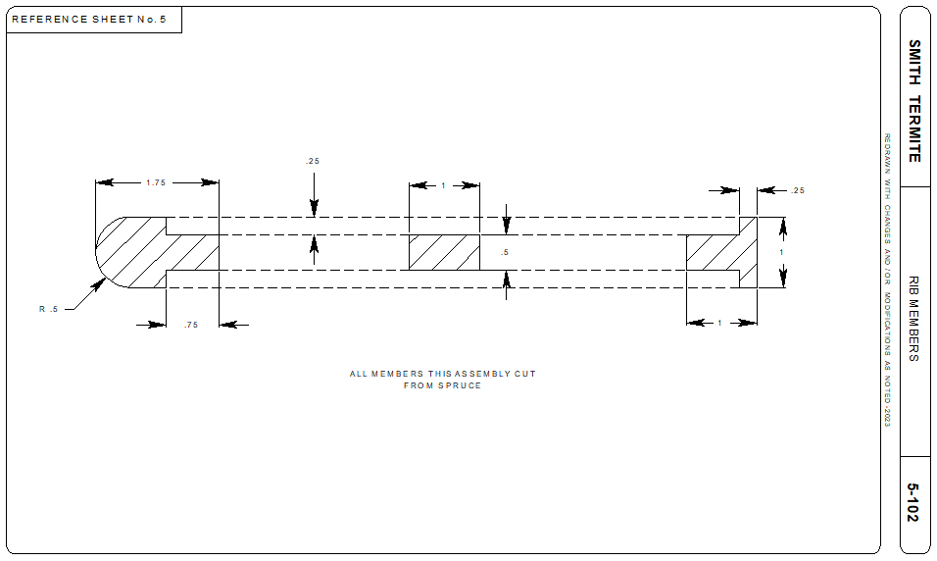
Illustration taken from CAD files.

Another full size jig is built to sit on a table for each flying surface. Start with the Horizontal Stabilizer. Block the leading edge and Spar beams in place and cut 1/4" x 1/2" Spruce strips to fit in between. Glue the lower "ribs" in place and glue the 1/2" x 1 1/4" "false" spar in place. Now glue in the upper rib strips and the 1/16" Mahogany ply rib webs. Rib webs are on the inner face of all ribs except the center which is plated on both sides. Finish this side by attaching the trailing edge gussets.

Remove the Horizontal Stabilizer from the jig, flip it over and glue the diagonal braces and Brace Wire fitting attach blocks (Oak or Spruce) into place. Pre drill the 3/16" holes for AN3 hardware. Attach the remaining 1/16" Mahogany ply gussets. The outer edge (Bow) can be cut from a piece of 1" x 6" Spar stock and glued together. Glue it in place and sand the cross section to desired shape. (Use the Router and the same bit as the leading edge for this operation BEFORE attaching the tip to the Horizontal Stabilizer.)

Cut the 1/8" Mahogany plywood strip for the aft face of the hinge spars and glue in place. Small squares of Mahogany ply should also be glued on the inner faces of spars centered over the hinge bolt holes in addition to the AN970-3 washers. Do this operation as you did on the wing by gluing one side at a time and drilling through the spar after sufficient drying time.

NOTE: The drawings shown in January 1958 of Sport Aviation show a fabricated hinge from .065" 4130 sheet and .375" 4130 tube with a .25" AN392 Clevis Pin replacing the AN42B Eye Bolts.

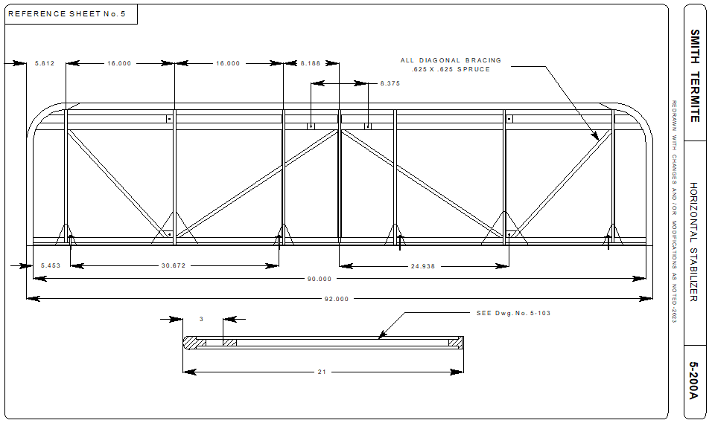
Illustration taken from CAD files.

The remaining tail surfaces are constructed exactly in the same manner including the laminated Rudder trailing edge. See Wing section. Note the Spruce blocking on the Elevator and Rudder ribs to reinforce the Horn locations.

NOTE: The drawing in Sport Aviation January 1958, shows a walking beam and pushrod for the Elevator. There are also photos of this method on the internet doing a "Smith Termite" image search. CAD drawings of this modification are available.

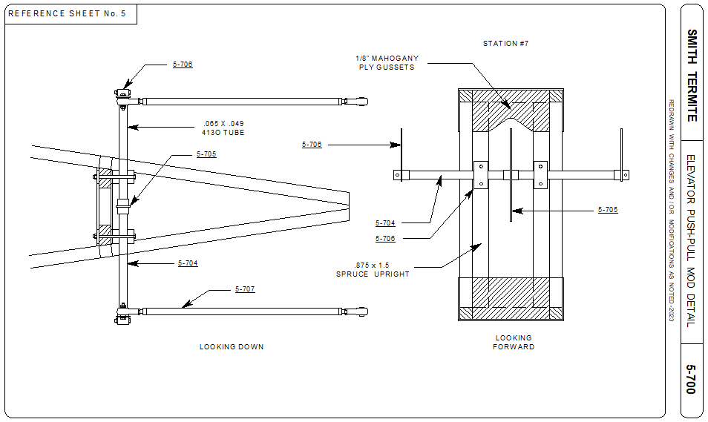
Illustration taken from CAD files.

There are no details of the Empennage attach fittings on the original drawings. However, the Sport Aviation drawing does show a fitting for the Vertical Fin. For the Horizontal Stabilizer (or both), the attach fittings for the Pietenpol would do as the basic construction of the tail surfaces mimics this design.

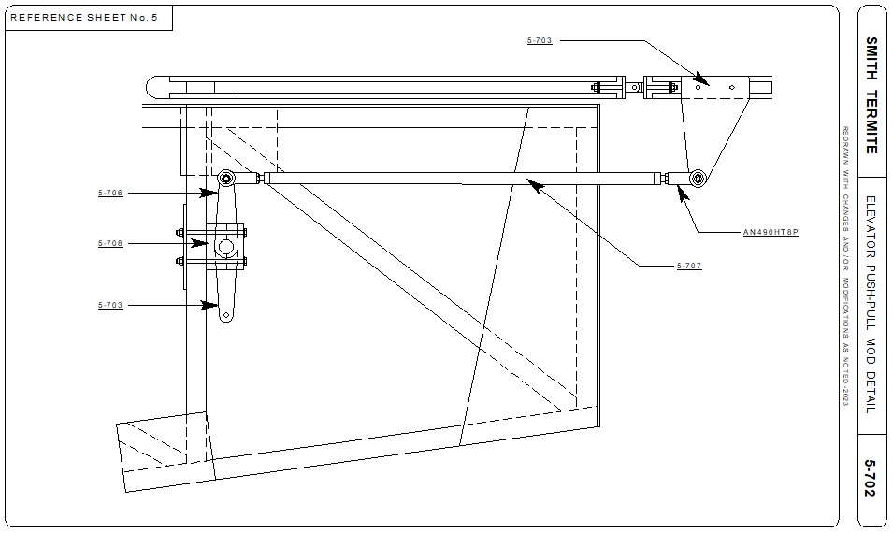
Illustration taken from CAD files.

METAL FITTINGS

All of the metal fittings should be made from 4130 sheet steel. Although you can cut these out by hand on a Band Saw, a shop that has a Water Jet or Laser cutter will save tens upon tens of hours of your labor, but will cost. If you do not have a .dxf CAD drawing of the parts, the shop can usually do this for you, but will charge for the hours and possibly a set-up fee for cutting. A disadvantage of the Laser process will be the heat hardens the edges of each part. Water Jetting does not. Follow general rules for forming the 4130 using the appropriate radius die for each thickness. The rule of thumb is the radius should be 1 1/2 times the material thickness.

To draw an accurate flat pattern, there are formulas you can find on the Internet which calculate the bend allowance and bend tangents. A plug-in spreadsheet is available for download on the Smith Termite web page and Facebook page. Find the material column, the radius, # of bends, and leg length following the diagram. The lengths for each segment of the part as well as the overall flat pattern length is calculated including the bend tangents. A decent sheet metal shop can figure this out also.\

The cut and formed metal fittings need to be "finished" in some manner. Choices include pint, plating or Powder Coat. Sand or glass bead blasting will prep the part and remove and scale or markings. Unseen parts can simply be painted with an aircraft primer such as SEM self etching green primer 39694 available in spray cans and quarts.

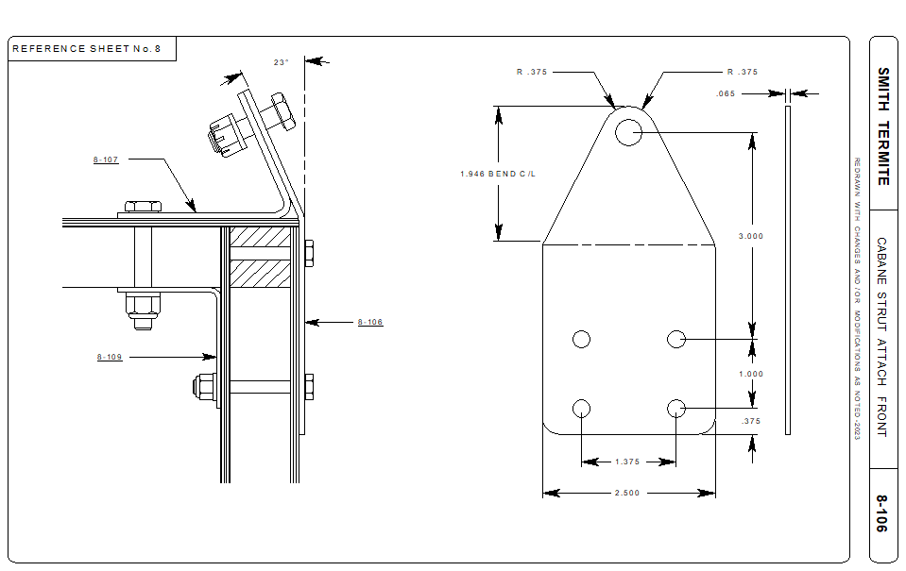
Illustration taken from CAD files.

Black Nickel plating per MIL-P-18317 will add to the corrosion resistance of metal fittings. This however, requires additional prep before painting.

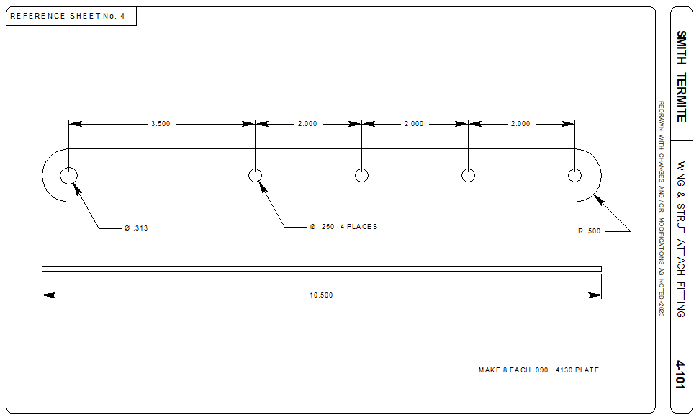
Illustration taken from CAD files.

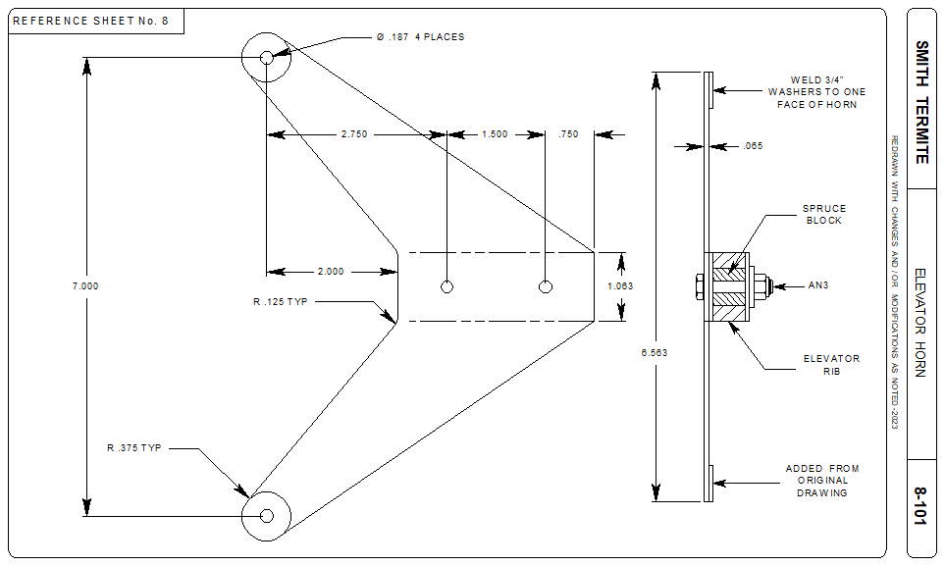
Illustration taken from CAD files.

LANDING GEAR

The original drawings call for a cut and modified Piper Cub J-3 gear legs, but shows next to nothing on how to manage that. The attach fittings didn't quite fit together as drawn, and the CAD showed the fittings center to center to be a bit wide if the fittings are built and installed as per plans. To achieve the 25" center to center of the fittings, the front attach assembly needs to be modified by relocating parts #2 and #3 on Sheet #7 to get that 25" measurement.

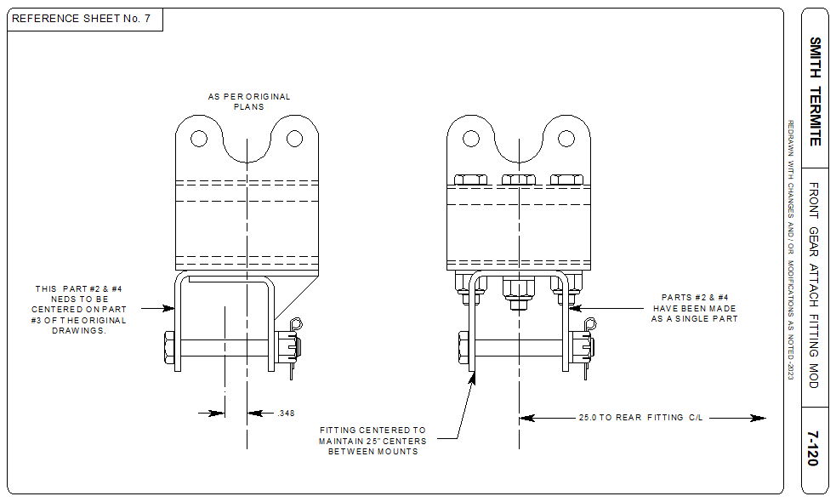
Illustration taken from CAD files.

Since the measurements of part #2 do not match the J-3 blueprints (See WagAero Sport Trainer drawings) the gear leg attach fitting needs to be modified (narrowed) to fit. It may be easier to begin new. Since many early homebuilt designs used the Cub gear style including the Grega Aircamper, so drawings are not difficult or expensive to acquire.

The original plans page #6 makes reference to a steel cross tube bolted between the gear fittings going across the fuselage, left to right. This can be fabricated using .75" X .75" X .049" square 4130 steel tube drilled to match the fitting attach bolts much like the Grega GN-1.

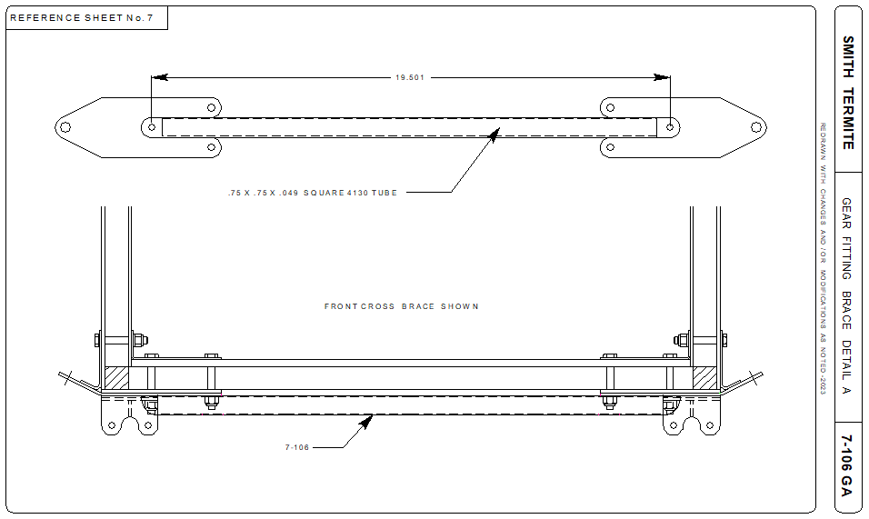
Illustration taken from CAD files.

The original plans, call for a .625" x .049" 4130 tube heated and flattened on the ends and then drilled. After heating, 4130 is near impossible to center punch or drill. The square tube is not.

The original Smith Termite had neither brakes or tail wheel, so adding those assemblies is up to the builder.

FLIGHT CONTROLS

The Termite flight control drawings found on Sheet #9 need very little if any modifications to the design. The CAD generated drawings added a second Control Stick attach fitting so there was balanced stress on the lower fitting. A 4130 reinforcement plate was drawn and is to be bolted below the Cockpit floor secured by the Control Stick mounting hardware. AN970 washers will also do in place of the plate. No errors on the original plans were found.

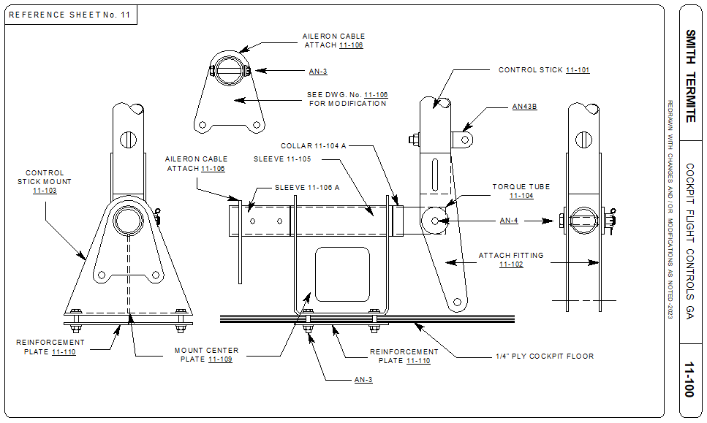
Illustration taken from CAD files.

Additionally, a second Aileron Horn on the Control Stick tube was added to again, center the stress on the fitting and to secure the cable end evenly (not shown on the CAD GA illustration).

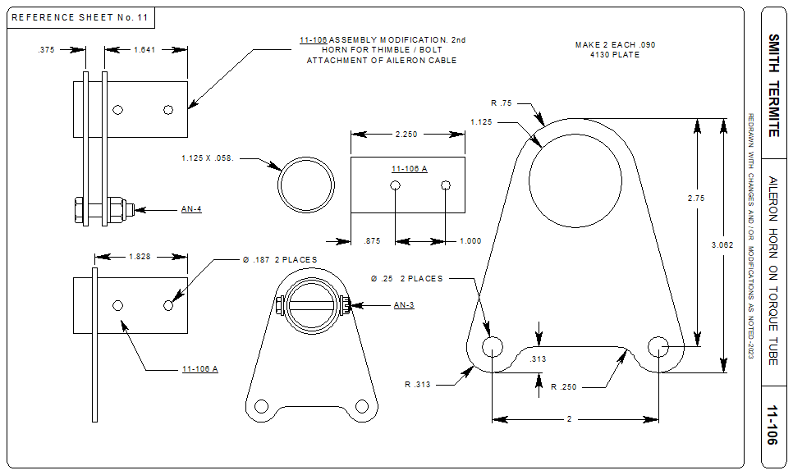
Illustration taken from CAD files.

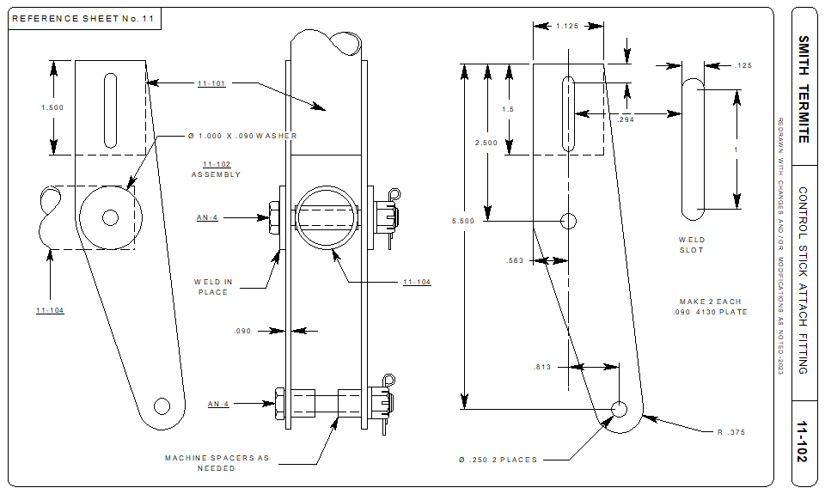
Illustration taken from CAD files.

REFERENCES AND RESOURCES

Acceptable Methods Techniques and Practices- Aircraft Inspection and Repair AC.43.13-1B

Aircraft Registration Application AC8050-1

Aircraft Bill of Sale AC8050-2

Repairman Certificate For Amateur Built Aircraft

You may obtain a repairman certificate for your own amateur-built aircraft if you built the major portion of the aircraft. The only privilege this certificate gives you is contained in 14 CFR section 65.104, "Repairman Certificate - experimental aircraft builder - Eligibility, privileges and limitations", i.e., to do the annual condition inspection.

The privileges and limitations for repairmen are in 14 CFR section 65.103, "Repairman certificate: Privileges and limitations". To obtain a certificate, apply through your local FAA Flight Standards District Office.

Experimental Aircraft Association
EAA Aviation Center
3000 Poberezny Rd
Oshkosh, WI 54903
920-426-4800

Sport Aviation Magazine, September1958
Feature article and illustration by Don Cookman.

REVISIONS

Please send any concerns or found errors in the plans or manual to plans@smithtermite.com- They will be reviewed and added to future plans and manuals and as a download on smithtermite.com download page.

PLANS

02/16/2023 Original plans pages Cover thru 12 have been "cleaned up" and saved as .tiff and .pdf files.

12/21/2023 Full size wing rib drawing completed in CAD. Modified construction.

MANUAL

02/17/2023 Original hand written manual typed by Mr. Mike Townsley (used with permission). Available as a download on the Smith Termite Facebook page.

02/21/2023 New Builders Manual completed with CAD generated illustrations.

Steven Speidel Enterprises
6000 W Dedham Trail, Crystal River FL 34429

SMITH TERMITE PLANS

Notice of Disclaimer, Waiver and Warning

These drawings, related manuals and any or all other materials or documents are furnished for EDUCATIONAL, RECREATIONAL or for any other PURPOSE to show typical construction of a homebuilt experimental aircraft designed in the 1950's. These drawings show the state of aircraft design in that period, and should be used for historical reference only and or as an example of wood constructed aircraft.

The Smith Termite plans contained herein are not intended for, nor should they be used to construct an actual full sized aircraft.

No warranty either expressed or implied is made by Steven Speidel Enterprises or the designer as to the suitability of these plans or any part thereof for the construction of an aircraft. IF an individual or group of individuals constructs and aircraft from these drawings or any part and fly the aircraft, they do so at their own risk and without any liability whatsoever on the part of Steven Speidel, the designer, all such liability being hereby expressly waived by the acceptance of these plans by any person and any person who flies the aircraft. This waiver shall be binding upon the heirs, executors, administrators and assigns of any such person.

The serial number provided on these drawings is for reference only by the seller as a means of identifying the original plans holder whose contact information is on file. The ownership of this plans set and the sequential identification number is NOT transferable to any other individual or party.

© STEVEN SPEIDEL 2023 "All rights reserved"

